**Kermanshah University of Medical Sciences Dazzles in Times Higher Education 2025 World Rankings**

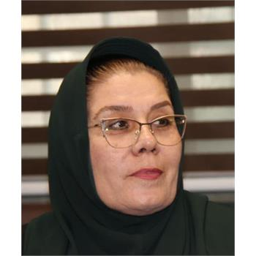

In a momentous announcement, the Public Relations Office of Kermanshah University of Medical Sciences has revealed the university’s stunning success in the latest subject rankings released by Times Higher Education (THE) for 2025. Dr. Zohreh Rahimi, Vice Chancellor for Research and Technology, emphasized the exceptional performance of Iranian universities on the global stage—heralding, in particular, the dazzling achievement of Kermanshah University of Medical Sciences in this fierce international competition.

According to an extensive report by Dr. Seyed Zia Hashemi, Deputy for Cultural and Social Affairs to the First Vice President of Iran, the ascension of both medical and non-medical Iranian universities in these prestigious global rankings has drawn national acclaim. Dr. Hashemi highlighted that, “In THE’s subject rankings, Sharif University of Technology captured the world’s 151–175th position in ‘Engineering’ and ‘Computer Science’—the highest standing among Iranian non-medical universities. Meanwhile, in the field of medical sciences, Kermanshah University of Medical Sciences has blazed a trail, clinching the top spot among Iranian medical universities and cementing its place in the outstanding 301–400 range worldwide—a remarkable and awe-inspiring accomplishment.”

He went on to stress the international credibility of the Times rankings, noting: “THE meticulously evaluates universities based on a broad and rigorous set of indicators—spanning teaching, research, citations, income from industry, and international collaboration. The inclusion of Kermanshah University of Medical Sciences among the world’s elite is clear testament to its relentless pursuit of quality, and to the dedication of its faculty, researchers, students, and staff.”

Dr. Rahimi, congratulating the academic community on this remarkable success, declared: “Achieving such a prestigious rank is a great honor for Kermanshah province and an emblem of our region’s scientific renaissance. This milestone marks a powerful stride toward the realization of our academic development goals, the advancement of higher education diplomacy, and the deepening of international scientific partnerships.”

She further extended her heartfelt gratitude to all university constituents for their tireless effort, and voiced her hopes for the future: “With this upward momentum, we fervently wish to see Kermanshah University of Medical Sciences continue to climb, shining ever brighter among the world’s leading centers of learning and research.”

Over the past few years, Kermanshah University of Medical Sciences has consistently demonstrated its commitment to academic excellence and research innovation. The university has steadily climbed various national and international rankings, earning recognition for its cutting-edge medical research, quality of education, and impactful community health initiatives. Notably, KUMS has been acknowledged among the top medical universities in Iran by leading educational assessments, while also being ranked within the top tiers in regional Asia-Pacific university evaluations. These sustained achievements have laid a strong foundation for the university’s current success in the prestigious Times Higher Education 2025 rankings.

This breathtaking leap in the global rankings stands as a beacon of hope, progress, and pride—not only for Kermanshah, but for Iranian science as a whole—emblazoning the university’s name upon the map of international academic excellence.